Joints 🡪 Cross Product + Condition

Find the employ name who is working in a department ???

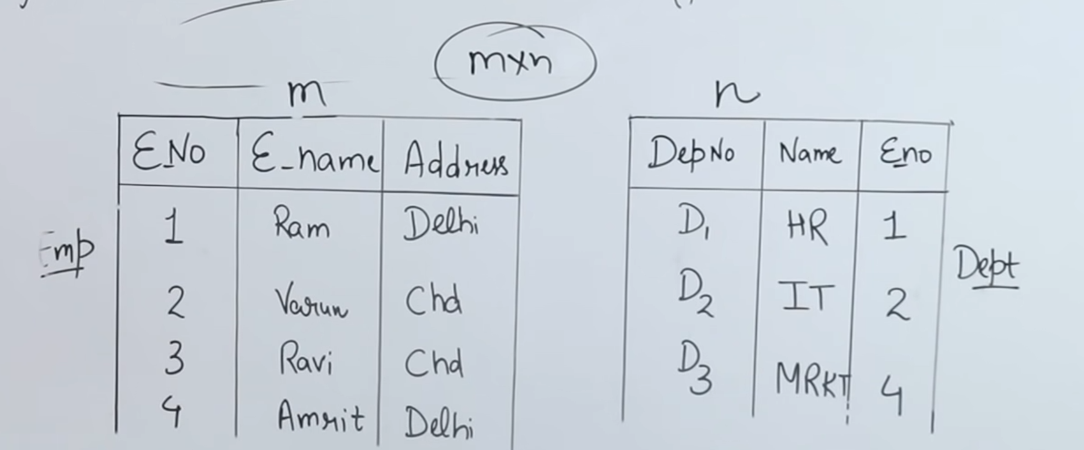  
select e-name from **Emp, Dept** where **Emp.e-no = Dept.e-no**







**Emp, Dept** (Cross product)

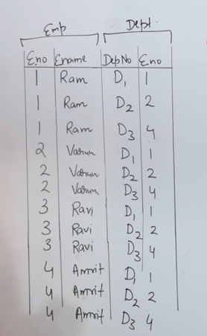

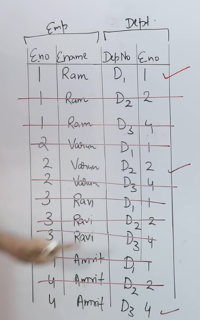

After merging from a cross product, only 3 rows will be available.

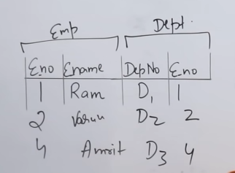

Exact query to retrieve the data using joints   
**select e-name from Emp Natural Join Dept** 



**Self Join**

A **self join** is a **join** in which a table is joined with itself (which is also called Unary relationships), especially when the table has a FOREIGN KEY which references its own PRIMARY KEY.

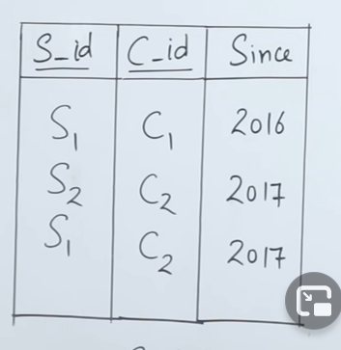   
 T1 T2

Creating the aliases of study table as T1 and T2.

Select ____ from Study as T1, Study as T2.

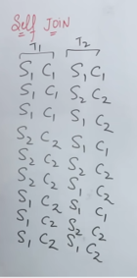



Condition 🡪 T1.sid = T2.sid and T1.cid <> T2.cid

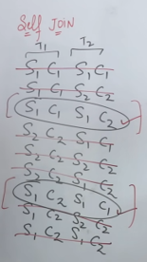

After the solving the condition, only 2 rows are left behind.  
<> means Not equal to .

2 sid are available, among that choose any one tables sid (i.e T1’s sid or T2’s sid)

Final query,  
**Select T1.sid from Study as T1, Study as T2 where  
T1.sid = T2.sid and T1.cid <> T2.cid**

**Final output 🡪 S1**

**spEqui Join**

Every natural join is a equi join but every equi join is not a natural join

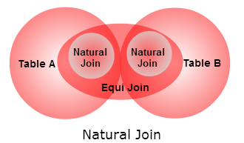

Natural join must have same attribute in both the table.  
Equi join can have same/different attribute in both the table.

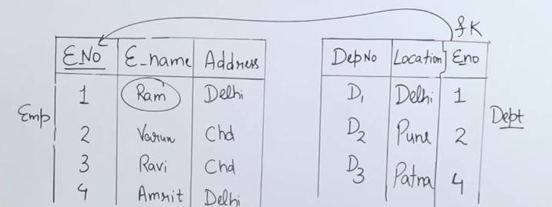

Emp, Dept 🡪 Cross product

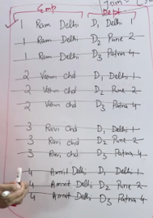

**Select e_name from Emp, Dept where   
 Emp.e_no = Dept.e_no and** (natural join/equi join) **Emp.address = Dept.location** (equi join and not natural join)

**Final output 🡪 Ram**